**Unraveling Stability Analysis and Genotype Selection in Maize (Zea mays L.) Using Advanced Statistical Tools: An Investigation with AMMI, BLUP, GGE Biplot, and MTSI.**

Chitra Bahadur Kuwar**1**, Bikas Basnet**2**, Samjhana. Sunuwar**3**, Deep Narayan Mahato**4**, Ramdas Chaudhari**5** Jharna Upadhya**1a**, Pragya Pokhrel**1a**

**1**Maize Coordinator, Seiner scientist (S4), National Maize Research Program, Rampur, Chitwan, Nepal.

**1a**National Maize Research Program, Rampur, Chitwan, Nepal.

**2\***Faculty of Agriculture, Agriculture and Forestry University, Bharatpur, Nepal.

**3**Regional Agriculture Research Station, Tarahara, Nepal

**4**Regional Agriculture Research Station, Parwanipur, Nepal

**5**Regional Agriculture Research Station, Nepalgunj, Nepal

*Corresponding author email: [bikasbasnet2001@gmail.com](mailto:bikasbasnet2001@gmail.com)

*Bikas Basnet Orchid id: 0000-0003-0579-6039

**Abstract:**

This study used advanced statistical methods to analyze Genotype-Environment interaction in 41 maize hybrids across four locations and two years. A Single-factor RCBD with three replication and Genotype by environment interaction (GEI) was examined using four cutting-edge statistical methods from the 'metan' package, aiming to identify varieties with consistent performance across wide environments. AMMI analysis revealed significant (p < 0.05) effects of genotype, environment, and genotype-environment interaction (GE), explaining 100% of the total yield variance. The interaction effects were captured by 3 principal components (IPCs). Stability analysis identified four varieties (MRM-4062, Super-22, PAC-744, and Gen-4118) with high yield stability and above-average performance. Additionally, eight varieties (4118, 4558, 5454, NMH1258, PAC 746, PAC 745 Gold, and SUPER 9090) exhibited superior yield, regardless of their stability. Nepalgunj exhibited the lowest Genotype Environment Interaction (GEI) value. Conversely, Rampur displayed an above-average GEI, indicating a strong ability to modulate genotype performance. GGE biplot revealed two potential mega-environments based on yield similarities. Nine high-yielding varieties (Supper 6768, Super 9396, PAC750, MBS5622, PAC745 Gold, MRM4065, NMH8392, Gen-4118, and Gen 4558) were identified as vertex varieties, signifying their superior performance across different environments. Nepalgunj and Parwanipur were identified as the most representative environments for varieties PAC-744 and MRM-4060. Rampur and Tarahara emerged as the most discriminating environments for varieties Gen-4118, Super-9090, and TMMH-826. Multi-Trait Stability Index (MTSI) identified Super-9090 as the most stable and high-yielding genotype, followed by NMH4040, Super-22, Gen-4118, MBS-1144, and NMH1255. Both the Best Linear Unbiased Prediction (BLUP) and Weighted Average Absolute Score Standardized by Yields (WAASBY) models, along with dendrogram analysis, confirmed the superior yield potential of 25+ maize hybrids. Gen-4118 ranked highest in terms of average yield, followed by NMH-8392, TMH2858, and others. Thus, Gen-4118, Super-9090, MRM-4062, NMH1258, NMH-8392, TMH2858, PAC 746, PAC 745 Gold, and SUPER 9090 emerge as the highest-yielding and most consistently high-performing varieties, offering promise for wide commercial farming across diverse environments.

**Keywords**: GEI **analysis**, High-**yielding hybrids**, **Environment influence**, Statistical models, Maize.

1. **Introduction:**

Unraveling maize's past, scientists discovered its ancestors had 10 chromosomes. Duplicated gene analysis hints at a surprising origin: hybridization, not self-duplication1. The maize genome is estimated to be around approx. 2.4 Gb in size2. Maize was domesticated from Balsas teosinte (Zea mays ssp. parviglumis) by a single domestication event in southern Mexico about 9,000 years ago3. In 2022/23, the global corn landscape is dominated by the United States, whose production is expected to reach a staggering 348.75 million tons. China and Brazil complete the podium, showcasing their significant contributions to the world's corn supply (https://www.statista.com/statistics/254292/global-corn-production-by-country/). From grain to silage, maize covered 197 million hectares in 20224.

Nepal's agricultural sector implemented changes to increase crop yields, resulting in a significant 37% (2,067K tons to 2,997,733 tons(3.06 **tons/ha** in 2022) increase in maize production over the last decade5. This surge coincided with a 258% increase in annual fertilizer usage (110,013 metric tons to 394,595 metric tons (97.8 kilograms/ha in 2021), highlighting its role in boosting agricultural output(https://knoema.com/atlas/Nepal/Fertilizer-consumption)6. A significant preference for open-pollinated maize varieties (83%) is evident among farmers, compared to hybrid varieties (17%)7. Increasing the use of better maize seeds is important for improving crop yield in Nepal. In 2022, only 20% of farmers were using these seeds (replaced seed), but the goal is to raise it to 33% by 2025(seed replacement rate). The main reasons for the low use of these seeds are a lack of availability, slow and narrow domain expansion for recommended varieties, and a big gap between actual and potential yield being harvested89. A new study suggests that climate change might open up doors for expanding agriculture in Nepal's high mountains. By 2100, an impressive 36,943 square kilometers of land could potentially be used for farming, particularly for growing cereals. However, there's a disconnect, people are actually leaving the high land where land sits unused and overgrown10.

Crop success is heavily influenced by environmental factors, not just the variety's genetic potential. Climate conditions and soil properties can significantly impact performance, leading to lower yields in farmers field compared to controlled trials. This "yield gap" highlights the need for thorough testing of different crop varieties before recommending them for specific areas. By evaluating varieties across diverse environments over several years, This study identify cultivars with both high yield potential and stable performance, ensuring optimal outcomes for farmers in their target regions11. Picking the best crop variety (genotype) is tricky because different environments can affect their performance in unpredictable ways (genotype-environment interaction). This complex interaction can weaken the influence of genes on important traits (heritability), making it harder to identify the best performers for specific areas1213. In plant breeding, stability refers to a genotype exhibiting a relatively constant phenotype across diverse environments, suggesting that not all environments respond predictably to improved conditions14. This aligns with the concept of homeostasis in quantitative genetics and can be considered a "biological" or "static" form of stability15.The additive mean multiplicative interaction (AMMI) model applies principal component analysis (PCA) to the genotype by environment data after combining the main effects of genotype and environment using analysis of variance. As a result, the model is able to condense the relationship and patterns of interaction between genotype and environment1516. Additionally, genotype environment interaction, or GEI, provides chances for breeders to choose varieties that have a good interaction with a specific region or wide adaptation 17. This can be achieved by cultivating varieties in different environments, recording their response, and finally selecting a superior and stable genotype18. The GGE biplot was employed to assess the effectiveness of ideal varieties in mega-environments. A mega-setting is described as a subset of the environments with winning varieties that are identical, or at least comparable19. It is not possible to represent genotype effects directly in AMMI2 biplots due to the fact that this method solely breaks down GE interaction effects in the PCA. Conversely, biplots analysis is thought to be a practical statistical method for creating superior and phenotypically stable cultivars, on multiple environment1320.Although the AMMI stability model is a graphic-based tool for modeling GEI, it is unable to take into account a linear mixed-effect model within the structure21. AMMI struggles to incorporate random effects and structured relationships between environments, which are essential features of LMMs. This can lead to biased estimates and limit its applicability in complex scenarios11. Best Linear Unbiased Prediction although BLUP is not a graphic-based tool to manage random GEI structure, it can produce accurate response estimates. A mixed-model version of AMMI, WAASB takes into account all IPCA (interaction Principle components axes for stability analysis and treats varieties as random variables22. The most widely used stability index, the AMMI Stability Value (ASV), is based on squared deviations. The WAASB index is more resilient and insensitive to outliers because it is based on absolute deviations1512. MTSI (Multi-Trait Stability Index) is a method used to select high-yielding and stable varieties in multi-environment trials. Compared to AMMI, BLUP, and GGE biplot, MTSI has the advantage of considering both mean performance and stability simultaneously because it takes into account the correlation structure among variables23. Varieties with performance closer to the ideal, as determined by their position in the factor analysis results, receive higher MTSI scores2425. BLUP has the advantage of accurately estimating the mean, especially in linear mixed models, and allowing optimal prediction of random effects2126.

High genotype-environment interaction for grain yield complicates the search for superior Maize hybrids that perform consistently across diverse environments. Modernizing Nepal's maize sector requires identifying stable, high-yielding varieties. This innovative research fills a critical gap by utilizing cutting-edge stability analysis methods to select ideal varieties for wider cultivation and recommendation. By moving beyond traditional OPVs and limited systems, this study paves the way for a more productive (hybrid maize) and resilient maize sector in Nepal. Further study in maize is essential, and there is significant scope for biofortification to enhance nutritional security using **CRISPR-based tools** 27.

1. **Results and Discussion**
   1. **Combined analysis of variance of AMMI model**

Maize yield was significantly impacted by both environmental factors and the genetic makeup of the plants, as well as their interaction, as revealed by a combined analysis of variance (ANOVA)28. This finding was highly significant (p < 0.05), indicating the strong influence of these factors on yield Table 1. A similar study conducted on sorghum indicates that significant GEI for grain yield/ha and panicle yield at p<0.0129. The study identified 18 interactions for yield per hectare, with a final root mean square error (RMSE) of 7.112178e-11. Interaction principal component analysis (PCA) identified three main components (IPCA1, IPCA2, and IPCA3) that collectively explained all (100%) of the total variance in yield. IPCA1 was the most significant contributor, explaining 43.9% of the variance, followed by IPCA2 (35.2%) and IPCA3 (20.9%). This study confirms that genetic diversity among maize varieties, environmental variations across testing locations, and their interaction play a crucial role in determining the variability observed in grain yield30. The results suggest that environmental factors and genotype-environment interaction (GEI) play a significantly greater role in influencing maize yield performance compared to the main effect of genotype alone31. This indicates that, in Nepal, environmental factors are the primary driver of yield variation between maize varieties. Analysis of variance data reveals that the minimum genotype-environment combination for yield is 2.87 tons/hectare, achieved by Super-9396 in Nepalgunj. Conversely, the maximum genotype-environment combination is 10.67 tons/hectare, achieved by NMH 8392 in Nepalgunj. In terms of environment alone, Nepalgunj (8.11 tons/hectare) exhibits the minimum yield, while Rampur (8.36 tons/hectare) exhibits the maximum yield. Overall, the coefficient of variation for yield is 13.15%, with a standard error of the mean of 0.03 and a standard deviation of 1.08.

Table AMMI model ANOVA for Grain Yield (t/ha) Across Locations (**2019-2021**)

|  |  |  |  |  |  |  |  |
| --- | --- | --- | --- | --- | --- | --- | --- |
| **Source** | **Df** | **Sum Sq** | **Mean Sq** | **F value** | **Pr(>F)** | **Proportion** | **Accumulated** |
| ENV | 3 | 9.32E+00 | 3.11E+00 | 3.23E+04 | 1.11E-16 | **NA** | NA |
| REP(ENV) | 8 | 7.69E-04 | 9.62E-05 | 1.44E-04 | 1.00E+00 | **NA** | NA |
| GEN | 40 | 3.19E+02 | 7.99E+00 | 1.20E+01 | 1.29E-57 | NA | NA |
| GEN:ENV | 119 | 2.61E+02 | 2.19E+00 | 3.29E+00 | 3.37E-23 | NA | NA |
| PC1 | 42 | 5.82E+01 | 1.38E+00 | 2.08E+00 | 1.00E-04 | 43.9 | 43.9 |
| PC2 | 40 | 4.66E+01 | 1.16E+00 | 1.75E+00 | 3.20E-03 | 35.2 | 79.1 |
| PC3 | 38 | 2.77E+01 | 7.28E-01 | 1.09E+00 | 3.29E-01 | 20.9 | 100 |
| Residuals | 789 | 5.26E+02 | 6.66E-01 | NA | NA | NA | NA |
| All variables with significant (p < 0.05) genotype-vs-environment interaction (18). Final RMSE: 7.112178e-11 | | | | | | | |

* 1. **Best linear unbiased prediction (BLUP):**

A substantial proportion of the traits examined displayed significant genotype-by-environment (GxE) interactions at a 5% significance threshold, as evaluated using the Likelihood Ratio Test (LRT) implemented in the gamem_met function of the metan R package. Nonetheless, for the traits Score value against *Helminthosporium* *maydis* (Maydis), plant height (PHT), ear height (EHT), ear-to-plant height ratio (E.P), and thousand-grain weight (TGW), GxE interactions were not statistically significant. This implies that these traits exhibit consistent expression across varying environmental conditions. Consequently, within this context, employing the BLUP (Best Linear Unbiased Prediction) approach is likely to yield more precise and dependable predictions of trait performance across diverse environments. The predicted mean values of the varieties for each of the significant GxE interaction studied traits are presented in Figure 1. Analysis of Best Linear Unbiased Prediction (BLUP) values revealed that over 34 varieties exhibited above-average yield performance. Varieties Gen-4118, NMH8392, Super 9090, and TMMH2858 displayed the highest mean grain yield potential among the studied hybrids. Gen Super-9396, MRM-4010 along with 23 varieties are below from threshold BLUP plot in terms of yield/ha. Similarly, a superior shelling percentage was observed in 16 varieties, with PAC-745 Gold, NMH-8392, and Gen-4558 exhibiting the highest values. Notably, cob diameter and length were also assessed, demonstrating high performance in over 18 varieties. Notably, Super-9090 and Gen-4558 exhibited the highest BLUP values for cob diameter, while Super-9090 and MBS-1144 followed MRM-4065 in terms of cob length.

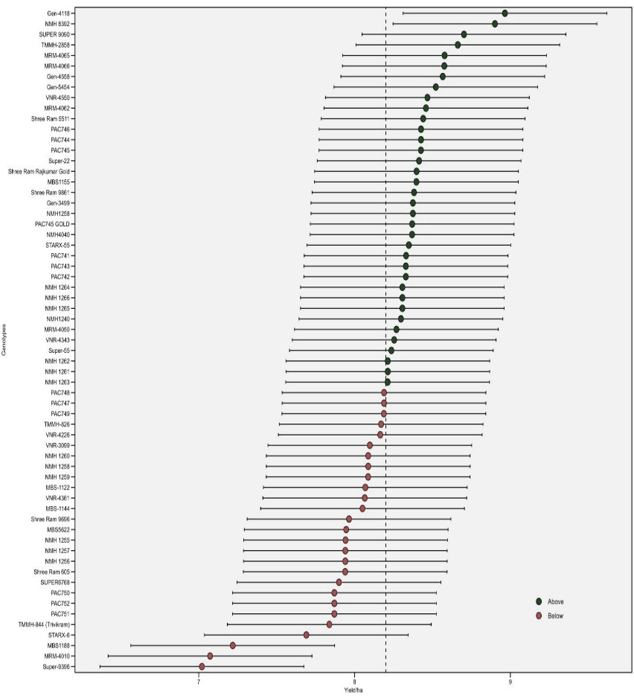

A

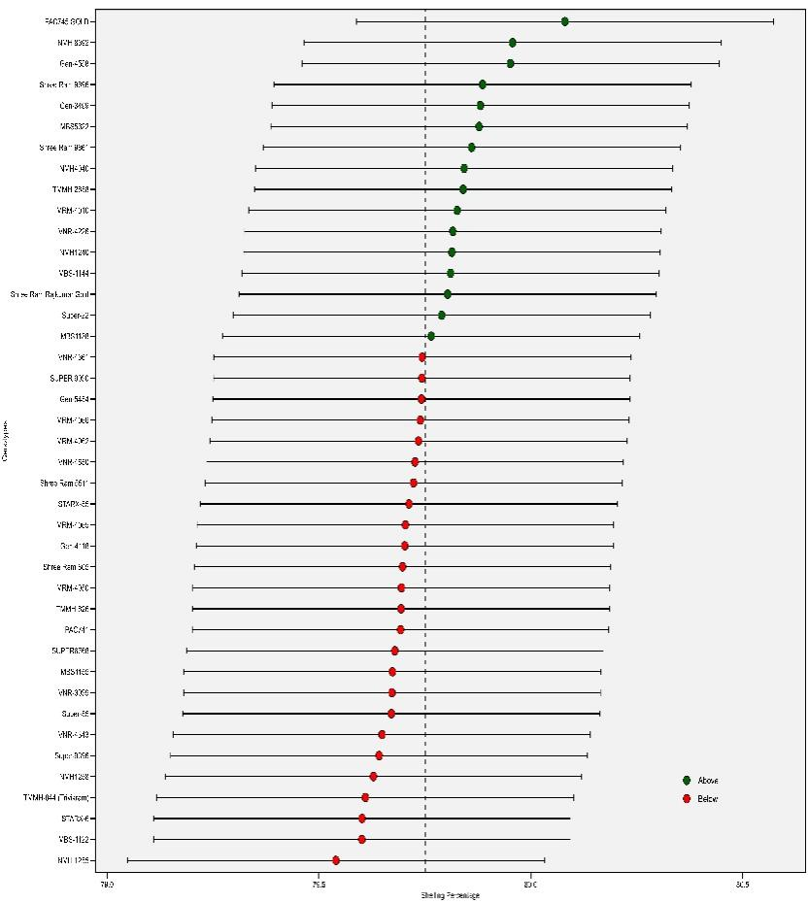

B

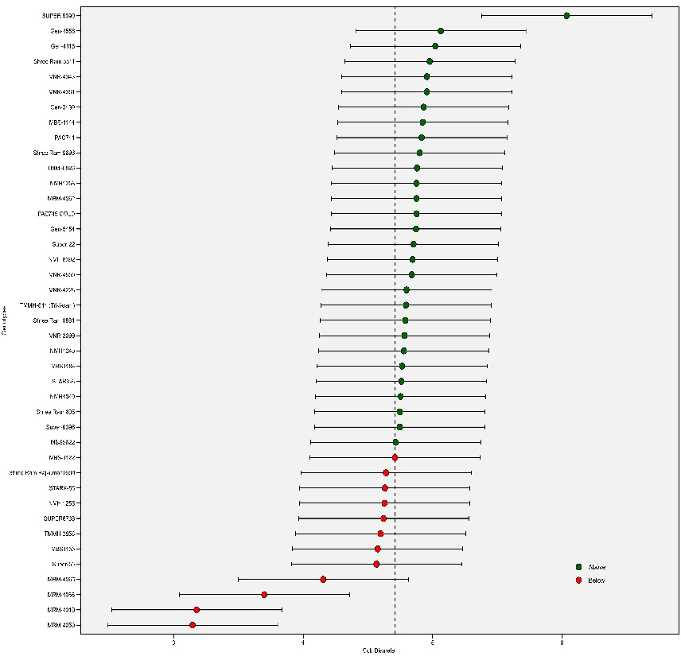

C

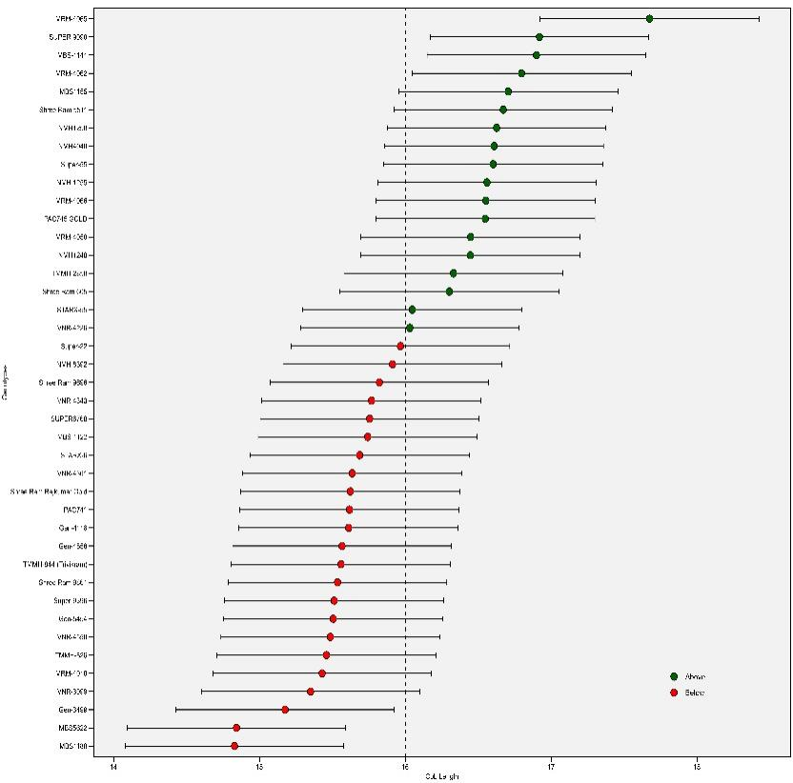

D

Figure 1 BLUP plot illustrating the mean values for four key traits (A) yield/ha, (B) Shelling Percentage, (C) Cob Diameter, and (D) Cob Length. Genotypes selected for their superior performance are highlighted in blue, while non-selected genotypes are marked in red.

Analysis of days to anthesis (DTA) revealed significant variation among varieties, with 15 exhibiting extended DTA exceeding 115 days. MRM 4065 displayed the longest DTA, followed by MRM 4062, VNR-4361, and PAC741, as depicted in Figure E. Conversely, MRM 4010 and Super-6768 demonstrated the shortest DTA and DTS, with values of 110 and 113 days, respectively (Figure F). Regarding ear aspect, 23 varieties exhibited superior values exceeding the BLUP plot threshold. MBS 1188 surpassed all other varieties with the highest ear aspect value, followed by VNR 3099 and MBS 5622 (Figure G). Notably, varieties MRM-4065, MRM4050, PAC741, and others displayed below-average ear aspect values, while VNR-4343, Shree Ram 5511, and MRM-4010 fell below the BLUP plot threshold Figure 2.

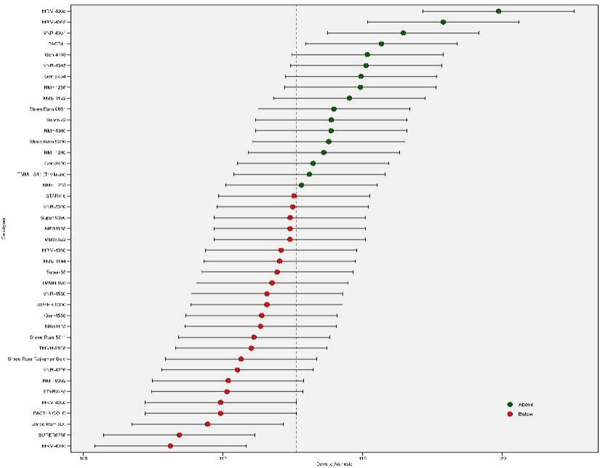

E

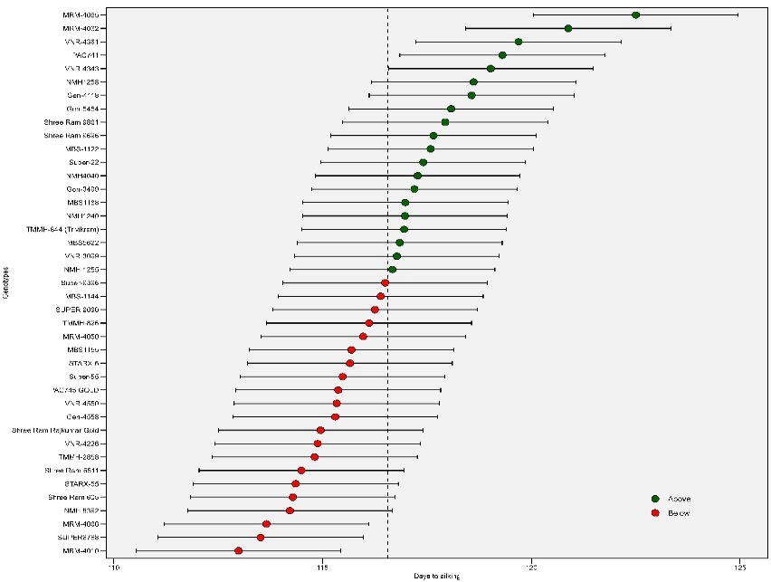

F

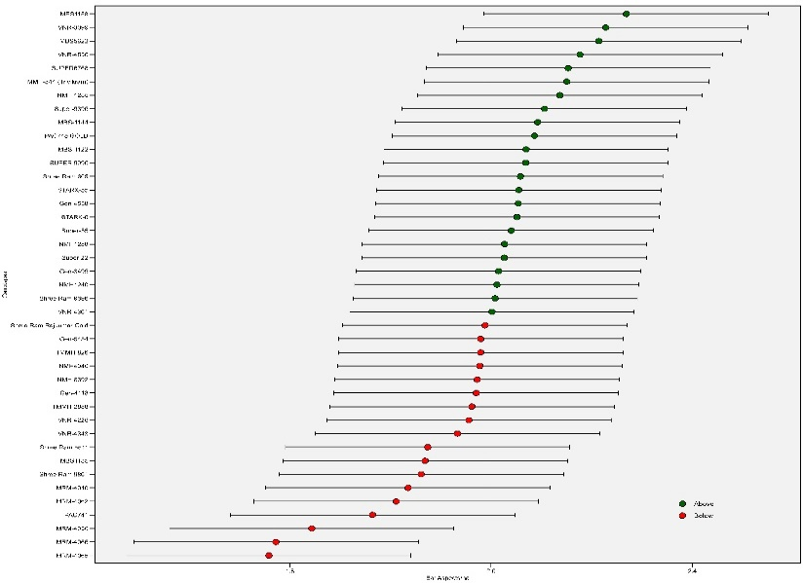

H

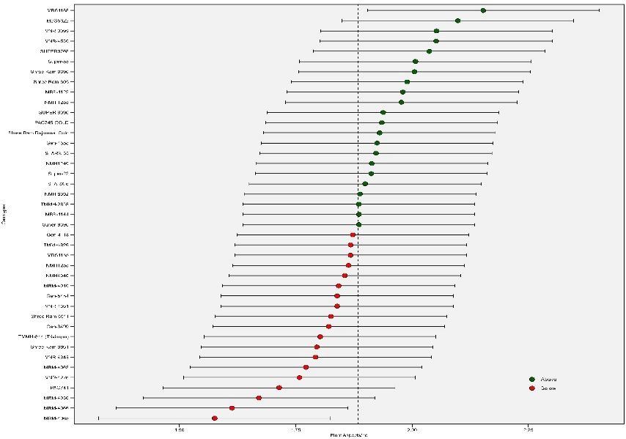

G

Figure 2 BLUP plot illustrating the mean values for four key traits. E days to anthesis, F days to silking, H: Plant asespects, G: Ear aspects. Genotypes selected for their superior performance are highlighted in blue, while non-selected genotypes are marked in red.

* 1. **WAASBY model for Yield**

Genotype selection can be accomplished concurrently by considering yield quantity and stability by utilizing the WAASBY (Weighted Average of Absolute Scores and Yield) index. The WAASBY index merges the WAASB index, a stability metric, with the yield value of the trait. This empowers breeders to pinpoint varieties that display both high yield and stability across diverse environments. In a study involving 41 maize varieties, WAASBY index evaluation revealed Gen-4118 as the top contender, trailed by TMMH-2858, Super 9090, Shree Ram 9861, and NMH1240. These varieties showcased superior productivity and stability across the assessed environments Figure 3. The WAASBY index serves as a valuable instrument for breeders striving to develop new crop varieties that amalgamate high yield and stability. By employing the WAASBY index, breeders can identify varieties that are well-suited to a broad spectrum of environments, guaranteeing farmers access to productive and dependable crops.

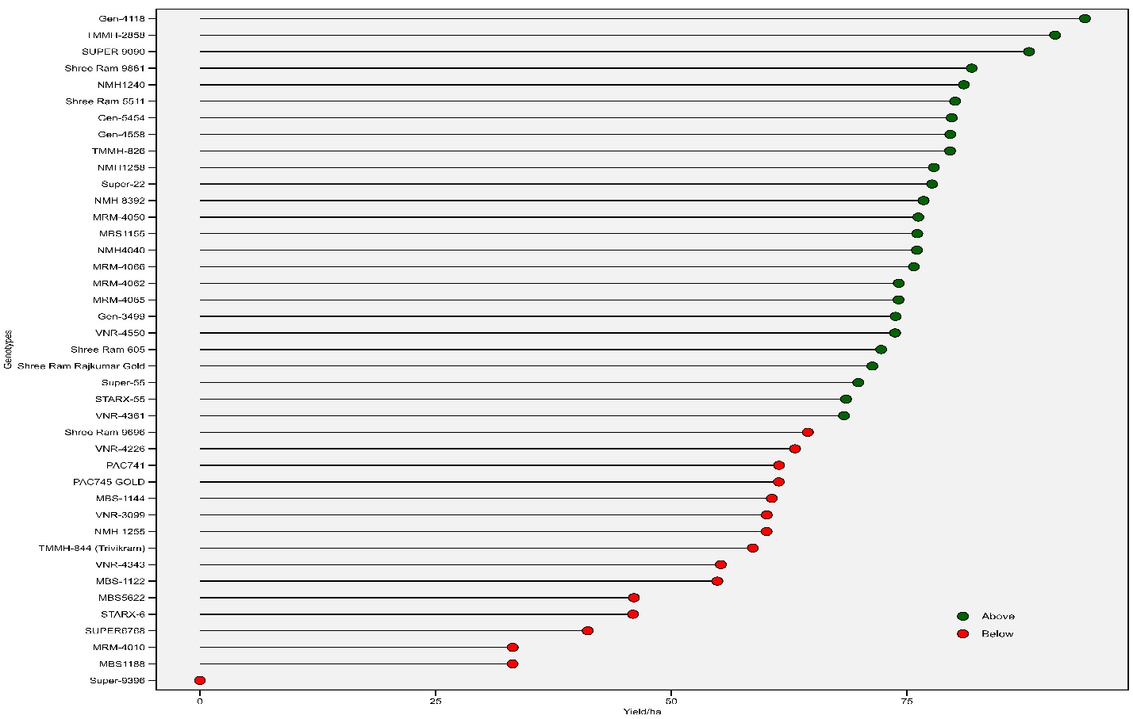

Figure 3 Analysis of 41 maize genotypes reveals the calculated values for the Weighted Average of Stability (WAASB) and Mean Performance (Y) (WAASBY), incorporating weightages based on yield/ha.

* 1. **Plotting the heat map graphics for the WAASB index and WAASB/GY ratio**

This analysis employs two heatmaps to examine how genotype ranking is affected by both PCA and WAASB/GY ratio. The first heatmap reveals(A) how genotype ranking changes with the number of PCA axes used for WAASB stability, with a dendrogram clustering varieties and axes based on their ranking proximity. The second(B) heatmap showcases how the WAASB/GY ratio, favoring stability or productivity depending on its value, influences genotype ranking. The WAAS/GY ratio acts as a balancing act between prioritizing genotype stability and productivity in ranking. A ratio of 100/0 focuses solely on stability, with varieties like Gen-4118 and NMH-8392 excelling in this regard. Conversely, a ratio of 0/100 prioritizes productivity, making TMH-826 and TMH-2858 the top performers. Super9396, MRM4010, and MBS 1188 fall at the other end of the spectrum, exhibiting the lowest levels of both stability and productivity *Figure 4.* A combined analysis of IPCA and WAASB/GY ratio revealed four distinct clusters of maize genotypes. The Red Cluster comprises genotypes characterized by both low productivity and instability, including Shree Ram9861, Shree Ram605, Shree Ram Raj Kumar Gold, NMH-4040 to MBS-1155. In contrast, the Blue Cluster encompasses genotypes that exhibit high productivity but are concurrently unstable, featuring SRARX-6, MRM-4010, Super-6768, MBS-5622 and MBS-1188. The Black Cluster is characterized by stable yet unproductive genotypes, such as Super-9396. Finally, the Green Cluster comprises genotypes marked by both high productivity and stability, exemplified by Tx-369 to GK3203.

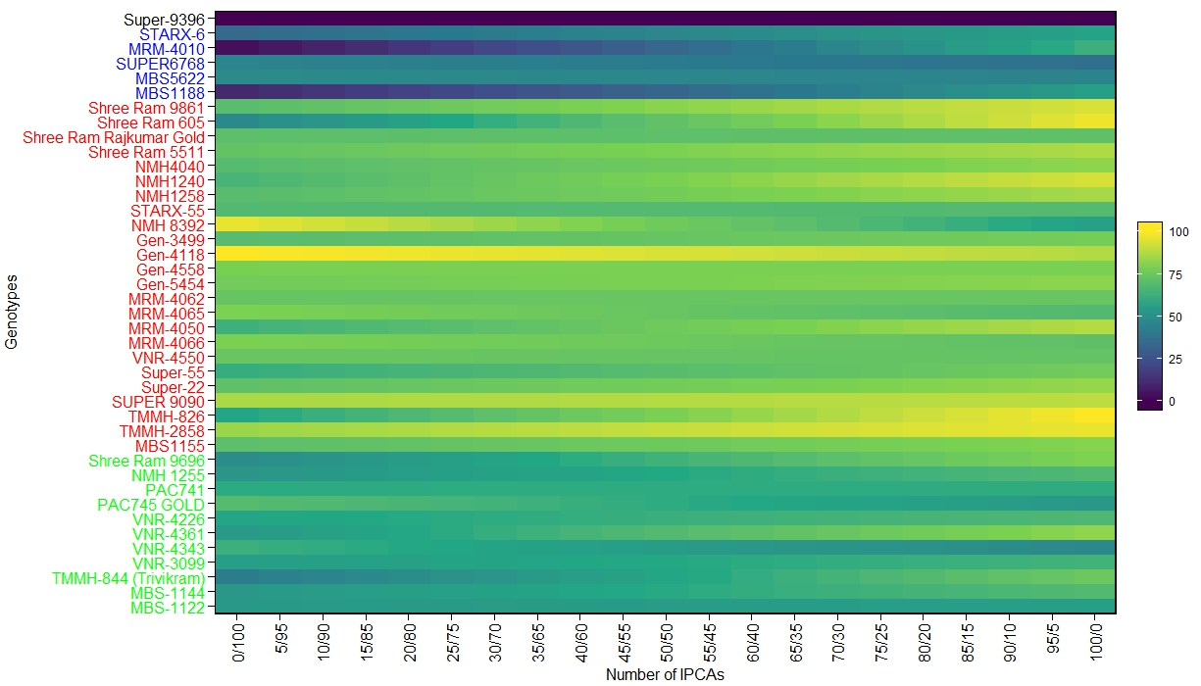

A

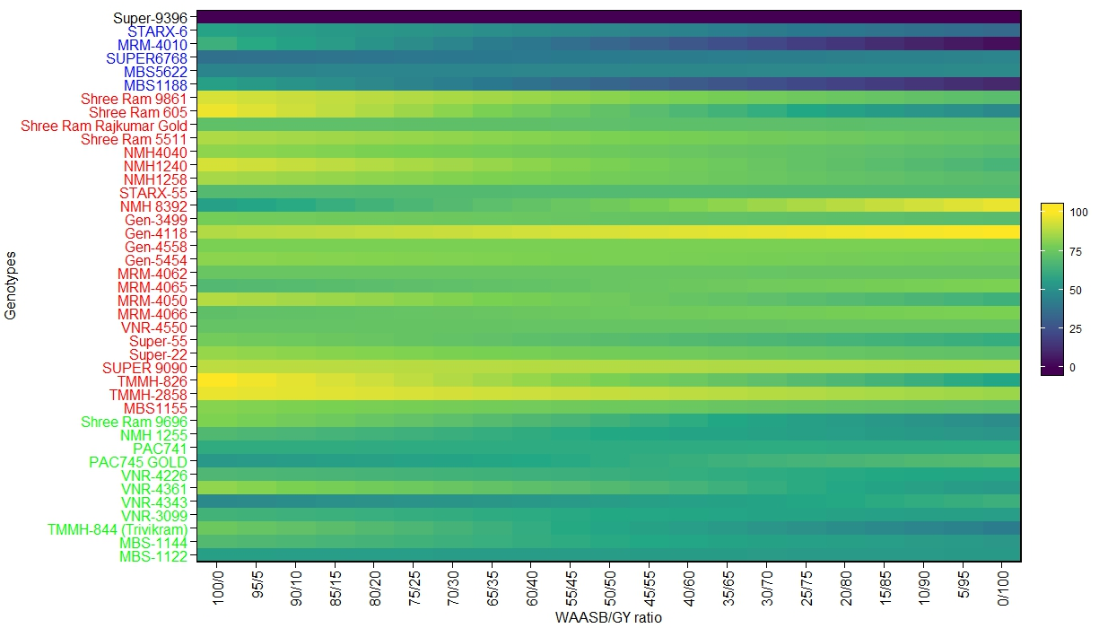

B

Figure 4 Ranks of genotypes illustrated by A) the number of Principal Components (PC) utilized for estimating the Weighted Average of Absolute Scores (WAAS), and B) the WAAS-to-Grain Yield (GY) ratio.

* 1. **AMMI (1 and 2) biplot analysis for Maize Hybrid Yield**

The AMMI1 biplot helps visualize the genotype by environment interaction (GEI) effect by plotting the mean yields of environments and varieties against their respective IPCA1 scores32. The x-axis of the biplot represents the average yield, with points to the right indicating higher-yielding varieties and environments, and points to the left indicating lower-yielding varieties and unfavorable, low-yielding environments. The y-axis of the biplot represents the IPCA1 score, which measures the contribution of the GEI effect to the overall yield variation33. Varieties and environments that are farther away from the origin of the biplot have a stronger GEI effect, meaning their yield performance varies more across different environments14342032. Among the environments, Rampur exhibited the highest mean yield and most favorable conditions, while Parwanipur, Tahrahara, and Nepalgunj demonstrated lower yields and less favorable conditions.

Similarly, Varieties 4118, 4558, 5454, NMH1258, PAC 746, PAC 744, PAC 745 Gold, and SUPER 9090 displayed superior yield performance, positioning them on the right side of the x-axis. In contrast, Varieties SUPER 9396, MRM4010, MBS 1188, STARX-6, SUPER6768, Shree Ram 9696, VNR4226, and TMMH826 exhibited lower mean yields, placing them on the left side of the x-axis, indicating their suitability for less favorable environments. Varieties with IPCA scores farther from zero, whether positive or negative, exhibit greater specificity to certain environments, indicating a stronger contribution to the genotype-by-environment interaction (GEI) effect. Conversely, varieties with IPCA scores closer to zero demonstrate greater stability across all environments sampled, implying a weaker GEI effect. Stability analysis revealed that varieties MRM-4062, Super-22, PAC-744, and Gen-4118 exhibited relatively high stability and above-average yield performance. In contrast, PAC-750, NMH-1255, and VNR-4361 demonstrated stability but below-average yield performance. Varieties VNR4226, VNR 4343, Super-6768, SUPER 9396, and Super 55 exhibited higher instability *Figure 5*. Environments with IPCA scores close to zero indicate low GEI across varieties and limited discrimination among varieties. Among the environments, Nepalgunj displayed the lowest GEI, suggesting low discriminatory power in distinguishing genotype performance. Conversely, Rampur exhibited above-average GEI, indicating a strong ability to differentiate genotype performance.

The AMMI2 biplot facilitates the visual interpretation of genotype-by-environment interaction (GEI) patterns and aids in identifying environments or varieties exhibiting high, medium, or low interaction effects1433. Varieties and environments plotted closer to the biplot's origin demonstrate minimal GEI, implying consistent performance across various environments. Conversely, varieties and environments positioned farther from the origin exhibit stronger GEI, indicating a more pronounced variation in performance across different environmental conditions. Moreover, varieties and environments plotted nearby share similar GEI patterns, suggesting comparable responses to environmental changes. The AMMI2 biplot effectively visualizes the interplay between environments and varieties, simultaneously portraying the contributions of the first two principal components of interaction (IPCA1 and IPCA2). IPCA1 and IPCA2 collectively explain 78% of the genotype-by-environment (GxE) interaction, with IPCA1 accounting for 46.1% and IPCA2 contributing 31.9%. Environments with short lines have less impact on how well different varieties perform, while environments with long lines have a bigger impact Consistent with this observation, Rampur and Nepalgunj are positioned far from the biplot origin, characterized by long spokes, indicating their significant contribution to GxE interactions. Parwanipur and Taharah, on the other hand, exhibit shorter vector lengths and negative mean yields, suggesting their minimal involvement in GxE interactions and their overall low yield potential.

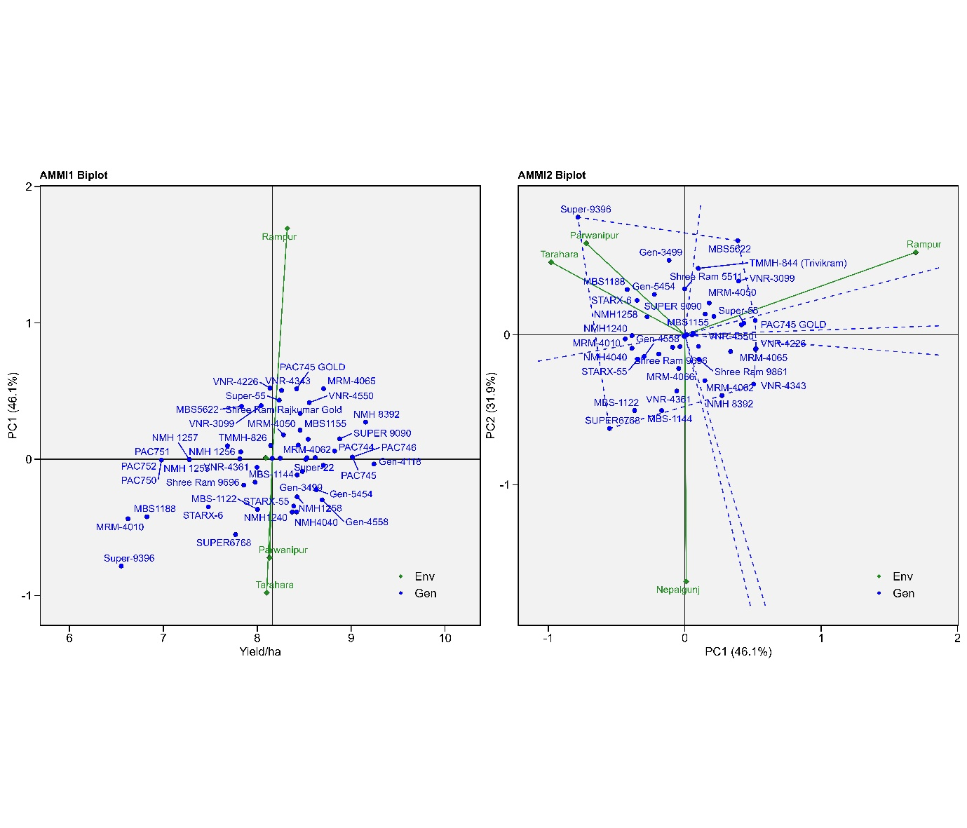

Figure 5 Illustrating the AMMI biplot, presenting the relationship between the first IPC axis and mean grain yield, as well as the interaction between IPCA1 and IPCA2 for 41 maize genotypes across four different environments.

* 1. **Which‑won‑where biplot**

To identify the most suitable genotype for each environment and assess genotype stability, a comprehensive GGE-biplot analysis was conducted. The resulting GGE-biplot, presented in Figure 1, effectively visualized the which-won-where patterns of maize hybrid yields (ton ha-1). This graphical representation provided valuable insights into the performance of various varieties across diverse environments. The GGE-biplot effectively captured 84.60% of the total variation in maize hybrid yields, with the first two principal component axes (IPCA1 and IPCA2) explaining 72.32% and 12.28% of the variation, respectively. These findings underscore the significance of these principal components in summarizing the underlying G × E interactions. A separate study on biofortified maize inbreeds line shows that GEI is highly significant at p≤0.01 for yield under stress and non-stress condition35. Nine vertex varieties, namely Supper 6768, Super 9396, PAC750, MBS5622, PAC745 Gold, MRM4065, NMH8392, Gen-4118, and Gen 4558, were connected to form a polygon, representing their grain yield performance. Nine lines drawn from the biplot's origin, intersecting the polygon's sides perpendicularly, divided the biplot into **eight** regions. Environments were categorized into two sectors based on their yield similarities, implying a potential division into two mega-environments. The most responsive genotype was the one with the farthest vertex from the biplot origin, exhibiting the highest yield among the environments within its sector. The first mega-environment comprised three environments: Tarahara, Parwanipur, and Nepalgunj. Varieties MRM4065 and PAC745 GOLD stood out as the winners in the second mega-environment, both possessing the longest vector lengths within their respective mega-environments *Figure 6*.

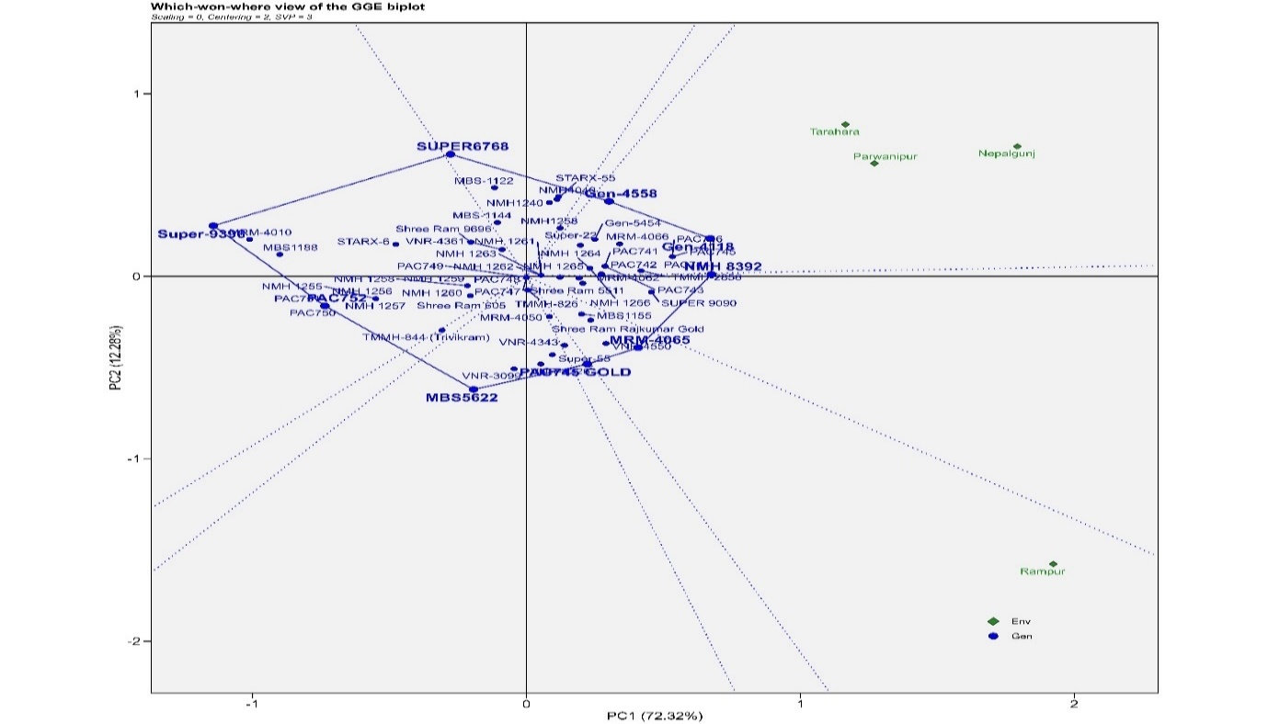

Figure 6 which won where GGE biplot over 4 different environments centered on grain yield/ha.

* 1. **Assessing Test Environment Quality: Unraveling Representativeness and Discriminating Ability**

In the pursuit of superior genotype selection for a thriving breeding program, pinpointing the most appropriate test environment is essential33. The discriminate versus representativeness biplot, showcased in *Figure 7*, serves as a valuable GGE biplot for assessing test environments. The stability of varieties is reflected by their proximity to the center of the circles, with varieties closer to the center demonstrating greater stability across diverse environments36. The concentric circles facilitate the identification of varieties that exhibit both stability and high yields across varying environments. In the context of GGE biplots, concentric circles serve the dual purpose of illustrating the length of environment vectors and measuring the discriminatory capacity of the environment14. As depicted in the image below, all varieties reside within the first and second concentric circles. Environments with high discriminating ability are adept at distinguishing between varieties based on their performance. These environments effectively separate varieties with varying yield potentials, enabling the precise identification of superior varieties. Representativeness indicates the similarity between the performance of varieties in the test environment and their performance in other environments20. The angle formed between the test environment and the average environment coordinate axis serves as a measure of both representativeness and discriminating ability34. A smaller angle signifies better representativeness and lower discriminating ability, implying that the test environment closely resembles the average environment1733. Conversely, a larger angle indicates lower representativeness and higher discriminating ability, suggesting that the test environment is unique and can effectively differentiate between varieties37. Highly discriminating test environments are particularly useful for identifying varieties with stable yields and specific environmental adaptations. The angle between two environment vectors reveals their relationship: positively correlated environments (angle < 90 degrees) exhibit similar genotype performance, while negatively correlated environments (angle > 90 degrees) show contrasting genotype performance. Environments with an angle of 90 degrees are independent, indicating no consistent relationship in genotype performance35. In this study, Rampur, Nepalgunj, Tarahara, and Parwanipur exhibited moderate discriminatory power, as evidenced by their relatively long vectors extending from the origin. Among these environments, Nepalgunj and Parwanipur displayed the highest representativeness and lowest discriminatory ability, indicated by their long vectors forming small angles with the AEC (Average Environment Curve) abscissa line. This suggests that these environments closely resemble the average environment and are less effective in differentiating between varieties. Conversely, Rampur and Tarahara demonstrated the highest discriminatory power and lowest representativeness, as indicated by their long vectors forming large angles with the AEC abscissa line. This implies that these environments are unique and can effectively distinguish between varieties.

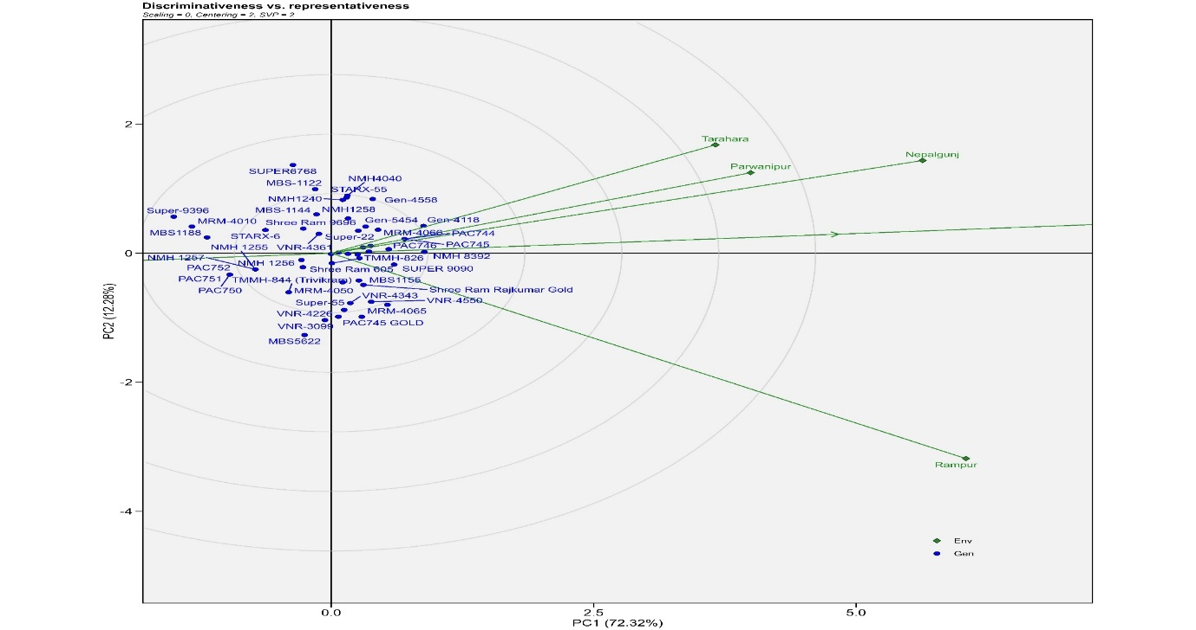

Figure 7 Ranking of 4 maize growing environments based on their discriminate and representativeness

Specifically, Nepalgunj and Parwanipur emerged as the most representative and least discriminative environments for varieties PAC-744 and MRM-4060. Conversely, Rampur and Tarahara were identified as the most discriminating and least representative environments for varieties Gen-4118, Super-9090, and TMMH-826. These findings highlight the importance of selecting appropriate test environments for genotype evaluation, considering both representativeness and discriminatory ability.

* 1. **Stability and average yield performance of the varieties**

To assess the stability and average yield performance of the 41 Maize Hybrid varieties, the average environment coordination (AEC) approach was employed. The stability axis, represented by a double-headed arrow axis that intersects the biplot origin at a right angle to the AEC, serves as a crucial indicator of genotype stability. Varieties located further from the AEC along either arrow are deemed less stable across environments, while those positioned closer to the AEC in the direction of either arrow are considered more stable. The varieties positioned nearest to the stability axis were Supper 9396, MBS1188, STAR 6, Shree Ram 605, TMMH-826, TMMH-2858, and Gen- 5454, Gen 4118, NMH-8392. These varieties were considered stable. The varieties further from the stability axis were MBS-5622, Super-6768, (**Trivikram**)-TMH-844, **PAC**-741, VNR-3099, and MBS-1122. These varieties were considered unstable. The ideal genotype is the one with the highest yield and the highest stability among environments**.** **Gen -4118,** **NMH-8392**, **TMMH-2858**, and **Gen-5454** were both stable and high-yielding and therefore considered ideal varieties. **Gen-4558 and MRM-4066, PAC-745 Gold, MRM-4065, and VNR4550** were higher yielders, but they were unstable. TMMH-826, Shree Ram 605, STARX-6, and MBS-1188 were relatively stable, but they were low yielders Figure 8.

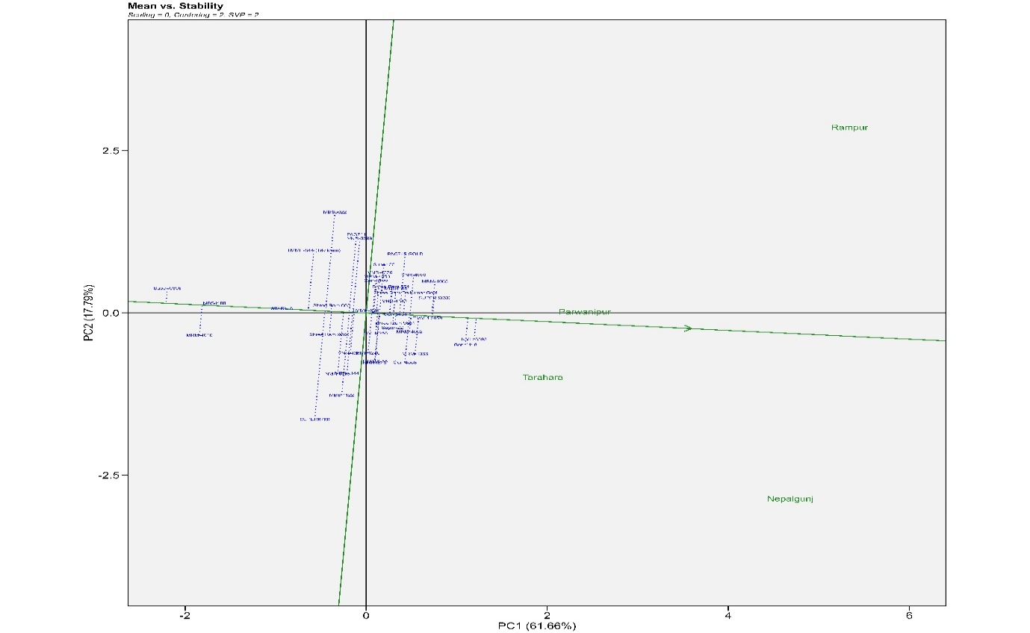

Figure 8 Mean Grain-yield versus stability biplot for the 41 maize genotypes and 4 environments

* 1. **Ranking varieties relative to the ideal varieties**

An analysis of 41 maize varieties grown in four different environments using a GGE biplot revealed that varieties closer to the center of the concentric circles had higher average yields. Varieties Gen4118, NMH-8392, TMMH-2858, Super-9090, MRM4065, and Gen-5454 were identified as the most desirable varieties due to their high yields and proximity to the ideal genotype. Varieties VNR-4550, VNR-4226, PAC-745Gold, Gen-4558, Super 22, and NMH-1258, located in the second concentric circle near the ideal genotype, exhibited both high yields and stability. Varieties Super-6768, MBS5622, MBS1122, PAC-741, and VNR-3099, positioned further from the ideal genotype, showed lower stability. Varieties Super 9396, MBS1188, MRM-4010, and MBS-1188, located outside the concentric circles, had low yields and were considered unsuitable for further breeding cycles ***Figure 9***.

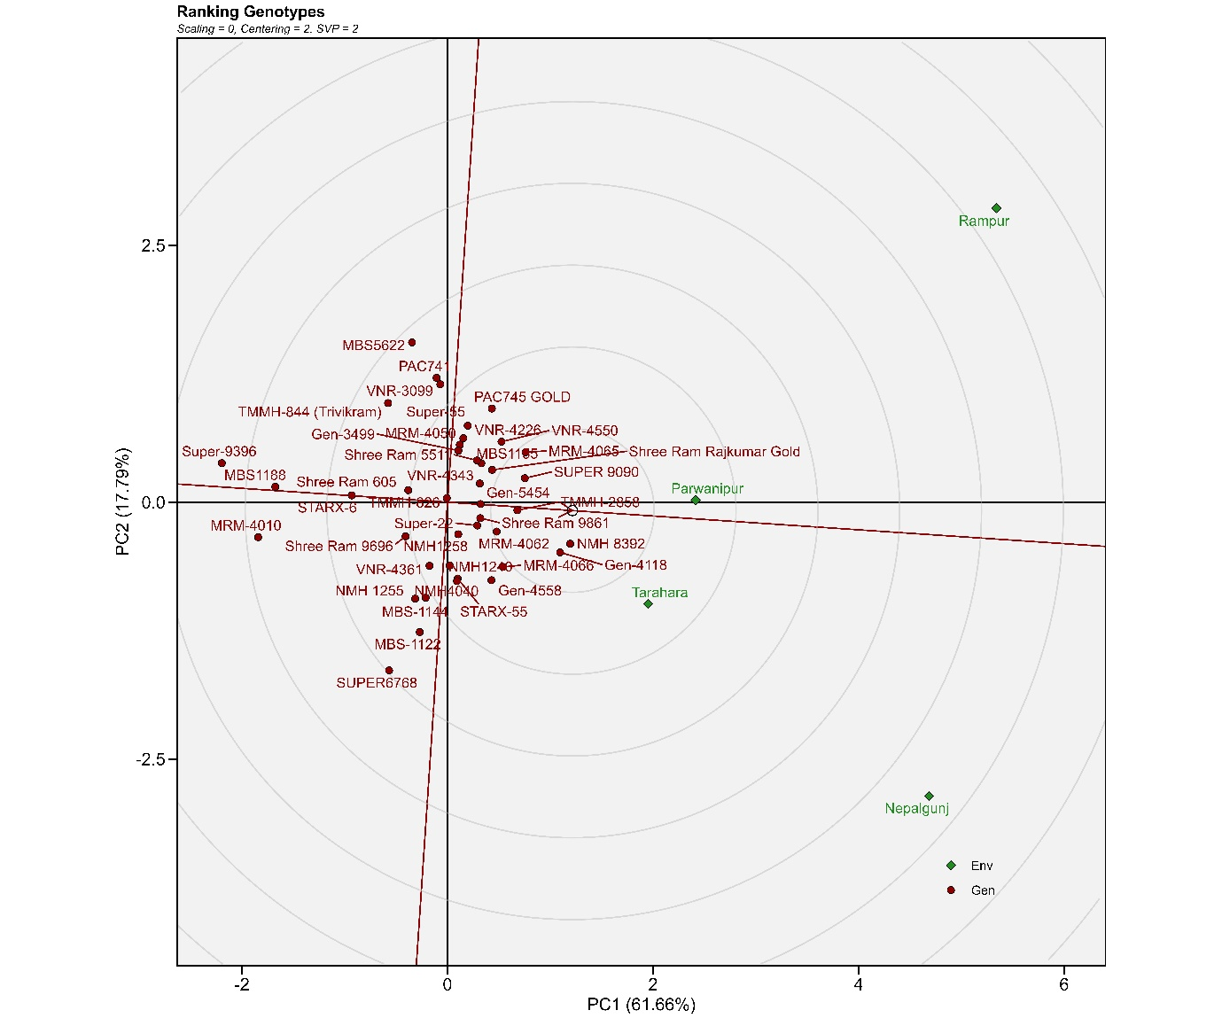

**Figure 9** Depicting the comparison and ranking of genotypes based on the ideal genotype

1. **Ranking and Relation between the Environment and with Ideal Environment**

An ideal environment is representative and has the highest discriminating power. The most suitable environment is the one closest to the ideal environment, which is located in the first concentric circle of the environment-focused GGE-biplot. Nepalgunj and Parwanipur are the most representative of the overall environments *Figure 10*.

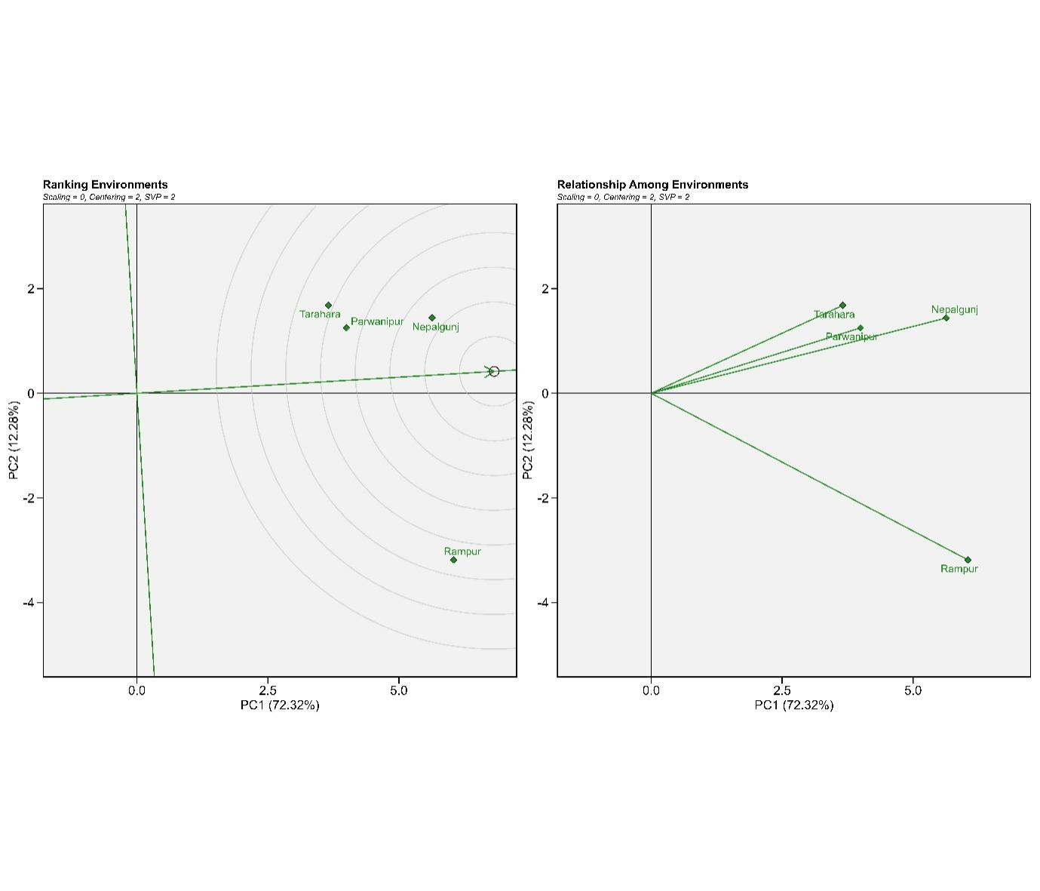

Figure 10 Biplot illustrating the ranking and relationships among environments

* 1. **Multi‑trait stability index (MTSI)**

Based on the MTSI value the selected varieties for stability and yield are denoted by red dot the experimental varieties are ranked from the highest to the lowest value of the MTSI so that the genotype with the highest value of MTSI is in the center and the genotype with the lowest value of MTSI is located in the outermost circle3823. Varieties determined in red color dots were selected based on their MTSI values at 20% selection intensity. Super-9090 was in the first rank followed by NMH4040, Super-22, Gen-4118, MBS-1144, and NMH1255 as the most ideal stable varieties. The strengths and weaknesses of the selected varieties are represented by the Rader plot in *Figure 11*. The factors analyzed, located at the center of the radar plot, are the most significant contributors to Factor Analysis (FA) and are less important for selection. The radar plot depicting strengths and weaknesses illustrates the strong and weak points of FA for each selected genotype. For Factor Analysis 1 (FA1), the least contributing varieties are MBS5622, MBS1188, and VNR-4550, which are located close to the boundary of the radar plot. Yield per hectare is associated with FA2, where the least contributing ideal varieties are NMH 8392, Gen-4118, and TMMH-2858.FA3, representing the most contributing varieties, includes VNR-4361, Gen-4118, and SUPER 9090, which are located close to the center of the radar plot. On the other hand, the least contributed varieties for FA7 are SUPER 9090, Shree Ram 5511, and MRM-4065, respectively.

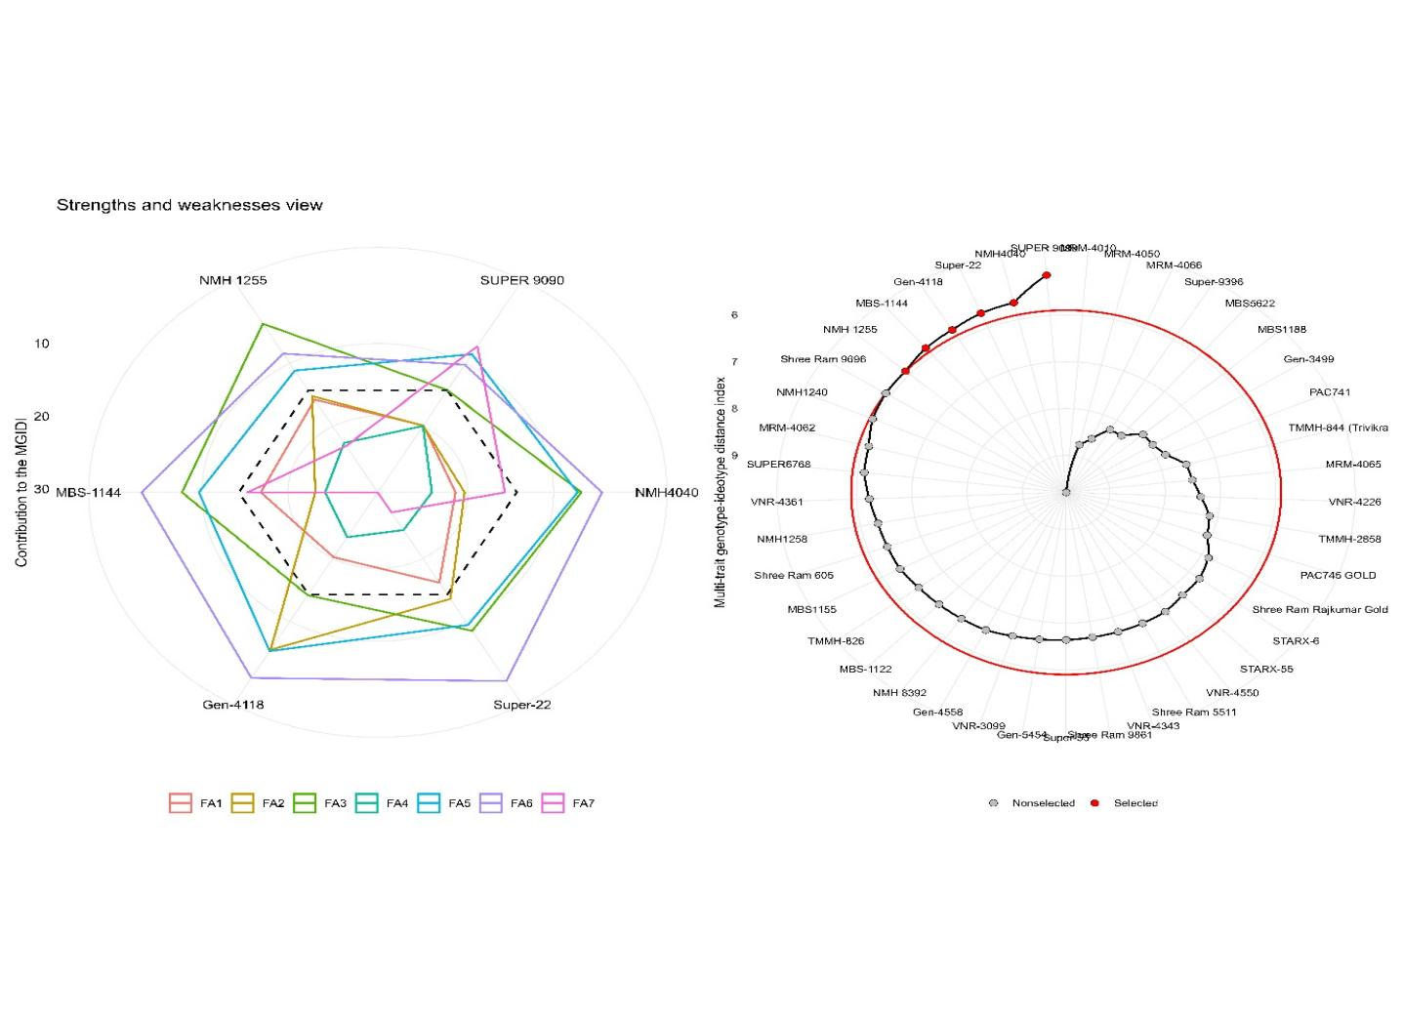

Figure 11 Ranking of maize genotypes in ascending order based on MTSI index

Comparison of mean phenotypic values of the selected parents with the population average revealed that all traits, except ear-to-plant ratio and shelling percentage, were higher in the parents. Pornification exhibited the highest heritability estimate (0.80), followed by ear-to-plant ratio (0.70), plant height (0.60), and cob diameter (0.51). In contrast, tassel-silking interval and shoot lodging displayed the lowest heritability estimates (0.03 and <0.01, respectively). Broad-sense heritability estimates exceeded 100% for all traits except root and shoot lodging. Notably, the projected selection gain for grain yield per hectare was modest, reaching only 0.13 units Table 2. All analyzed traits were categorized into Functional Analysis (FA) groups based on their genetic architecture and relationship to agronomic performance. FA1 grouped traits associated with grain protection and development, including husk cover, plant aspect (shape), and cob diameter. FA2 encompassed yield-related traits such as final plant and ear stands per hectare, and grain yield per hectare. FA3 combined traits related to plant structure and resilience, including root lodging, prolificacy, grain per row, and grains per cob. FA4 grouped traits related to plant morphology and development timing, including shoot lodging, plant height, ear height, and ear-to-plant ratio. FA5 encompassed phenological traits related to flowering and maturity, including days to anthesis, days to silking, and tassel-silking interval. Finally, FA6 contained the single trait of shelling percentage, while FA7 included only cob length.

Table 2 Prediction of selection differential for studied traits based on the MTSI index.

|  |  |  |  |  |  |  |  |  |  |  |
| --- | --- | --- | --- | --- | --- | --- | --- | --- | --- | --- |
| **VAR** | **Factor** | **Xo** | **Xs** | **SD** | **SDperc** | **h2** | **SG** | **SGperc** | **sense** | **goal** |
| HC | FA1 | 1.75 | 1.81 | 0.06 | 3.31 | 0.37 | 0.02 | 1.22 | increase | 100 |
| PA | FA1 | 1.88 | 1.91 | 0.02 | 1.17 | 0.34 | 0.01 | 0.39 | increase | 100 |
| EA | FA1 | 1.99 | 2.05 | 0.06 | 2.87 | 0.33 | 0.02 | 0.96 | increase | 100 |
| CoD | FA1 | 4.71 | 5.09 | 0.38 | 7.98 | **0.51** | 0.19 | 4.03 | increase | 100 |
| P.Ha | FA2 | 59,135.05 | 59,747.19 | 612.13 | 1.04 | 0.20 | 120.76 | 0.20 | increase | 100 |
| EH.Ha | FA2 | 62,613.49 | 63,346.51 | 733.02 | 1.17 | 0.24 | 172.35 | 0.28 | increase | 100 |
| Y.ha | FA2 | 8.20 | 8.46 | 0.26 | 3.15 | 0.51 | 0.13 | 1.60 | increase | 100 |
| RotL | FA3 | 1.63 | 1.70 | 0.07 | 4.27 | 0.24 | 0.02 | 1.04 | **decrease** | 0 |
| ProLi | FA3 | 1.03 | 1.05 | 0.02 | 1.97 | **0.82** | 0.02 | 1.61 | increase | 100 |
| GP.R | FA3 | 26.66 | 26.84 | 0.18 | 0.68 | 0.46 | 0.08 | 0.32 | increase | 100 |
| GR.C | FA3 | 20.99 | 21.13 | 0.13 | 0.64 | 0.44 | 0.06 | 0.28 | increase | 100 |
| ShtLod | FA4 | 1.76 | 1.78 | 0.02 | 1.41 | 0.12 | 0.00 | 0.17 | **decrease** | 0 |
| PHT | FA4 | 191.58 | 204.81 | 13.24 | 6.91 | **0.60** | 7.99 | 4.17 | increase | 100 |
| EHT | FA4 | 91.92 | 95.22 | 3.30 | 3.59 | 0.49 | 1.61 | 1.76 | increase | 100 |
| E.P | FA4 | 0.51 | > 0.47 | -0.04 | -7.99 | **0.70** | -0.03 | -5.57 | increase | 0 |
| DTA | FA5 | 114.11 | 114.53 | 0.42 | 0.37 | 0.17 | 0.07 | 0.06 | increase | 100 |
| DTS | FA5 | 116.57 | 117.10 | 0.54 | 0.46 | 0.20 | 0.11 | 0.09 | increase | 100 |
| TSI | FA5 | -2.46 | -2.48 | -0.02 | -0.96 | 0.03 | -0.00 | 0.03 | increase | 0 |
| SP | FA6 | 79.75 | > 79.71 | -0.04 | -0.05 | 0.25 | -0.01 | -0.01 | increase | 0 |
| CoL | FA7 | 16.00 | 16.48 | 0.48 | 2.98 | 0.47 | 0.22 | 1.40 | increase | 100 |
| HC: Husk cover, PA: Plant aspect, EA: ear aspects, CoD: Cob Diameter, P.Ha: Final plant stands/ha, Y.ha: Final ear  /ha, RotLi: Root Lodging. ShtLod: Shoot Lodging, PHT: plant height, EA: ear height, E:P: ear to plant ratio, DTA:  Days to anthesis, DTS: Days to silking, TSI: Tassel silking Interval, SP: Shelling Percentage, CoL: Cob length  Xo: Population mean, Xs: Selected pants mean, SD: selection differential, SD: selection differential percentage,  H2: broad sense heritability, SG: selection gain, SG%: selection gain percentage.original value, Xs selected value,  SD selection differential, SD perc selection differential in percentage, h2 broad sense heritability. | | | | | | | | | | |

1. **Materials and Methods:** 
   1. **EXPERIMENTAL DESIGN, SITE AND GERMPLASM INFORMATION**

A two-year experiment (2019-2021) was conducted on four research stations representing diverse climates across Nepal. These stations were Tarahara in the east (humid), Pawanipur in Bara (intermediate), Chitwan (maize research hub), and Nepalgunj in the far west (dry). A factorial randomized complete block design with three replications was employed for the experiment. This study evaluated the 41 Multinational companies and National Maize Research programme seed maize hybrid was evaluated across the location for performance and stability analysis. Maximize yield with optimal spacing: 60x25cm between plants and rows, for rows stretching 5 meters long. Sowing of seed was performed during 13November, (2019-2020& 2020-2021)- 23 November, (2019-2020& 2020-2021) from east to west in two season (**२०७६ कार्तिक २७ बुधवार-२०७६ मंसिर ७ शनिवार)**

* 1. **Measured Traits**

This study assessed 24 phenotypic markers in maize, including root and shoot lodging, days to anthesis and silking, tassel-silking interval, plant and ear height, ear-to-plant ratio, final plant and ear density (per hectare), prolification scoring, Turcicum maydis and insect damage scores, plant and ear aspect ratings, cob diameter and length, grain row number and grains per row, sellable grain percentage, thousand-grain weight (per hectare), and final grain yield (per hectare). The primary focus of the study was on grain yield for stability and yield analysis

* 1. **Statistical analysis:**

The data was entered into Excel and subsequently analyzed using R programming (R version 4.3.1 (2023-06-16 ucrt)). The metan package was employed for AMMI, GGE, BLUP, and MTSI model analysis. Joint analysis of variance (ANOVA) was used for pooled analysis. For the AMMI model, the performs_ammi function facilitated multiplicative interaction analysis, while plot_scores and ammi_indexes functions were utilized for AMMI biplot visualization and index value calculation, respectively. Index types 3, 4, 6, 8, and 10 were used for environment calculations (stability, representativeness, ranking, genotype ranking, and environmental relationships, respectively). The 'gge' function provided insights into genotype performance and stability across environments, and plot_waasby generated WAASBY plots. BLUP analysis was achieved using the gamem_met function. Finally, ggplot2's ggsave function enabled high-resolution figure export. Code used for this study is deposited on git-hub libraries(<https://github.com/Bikasbasnettest/PCA-cluster-biplot-AMMI-MTSI-WASB-ANALYISS-CODE->)

* 1. **For linear mixed model:**

$y=Xβ+Zu+e…………………………………………………………….$

where β is the data vector of the fixed unknown effect (the average value of the block in each environment), u is the GEI + genotype effect, X and Z represent the matrix involving β, u, and Y, and ε is the random error vector.

* 1. **Additive Main effects and Multiplicative Interaction**

Compute the Additive Main effects and Multiplicative interaction (AMMI) model. The estimate of the response variable for the ith genotype in the jth environment () using the AMMI model, is given as follows:

$$y_{ij}= μ+α_{i}+r_{j}+\sum_{k=1}^{p}{λ_{k}α_{ik}t_{jk}+p_{ij+ε_{ij}}}…………………………$$

where λk is the singular value for the kth interaction principal component axis (IPCA); αik is the ith element of the kth eigenvector; tjk is the jth element of the kth eigenvector. A residual pij remains if not all p IPCA are used, where p ≤min(g-1;e-1).

* 1. **Weighted Average of Absolute Scores:**

Compute the Weighted Average of Absolute Scores (Olivoto et al., 2019) for quantifying the stability of *g* varieties conducted in *e* environments using linear mixed-effect models. The weighted average of absolute scores is computed considering all Interaction Principal Component Axis (IPCA) from the Singular Value Decomposition (SVD) of the matrix of genotype-environment interaction (GEI) effects generated by a linear mixed-effect model, as follows:

$${WAASB}_{I}=\sum_{K=1}^{p}{{|PCA}_{jk}x{EP}_{K}|\frac{1}{\sum_{K=1}^{P}{{EP}_{K}}}…………………………. }$$

where WAASBi is the weighted average of absolute scores of the ith genotype; IPCAjk  is the score of the ith genotype in the kth Interaction Principal Component Axis (IPCA); and is the explained variance of the kth IPCA for k = 1,2,..,p, considering p ≤min(g-1;e-1).

* 1. **Multi-Trait Genotype-Ideotype Distance Index (MTGID)**

$${\dot{MGIDI}}_{i}=\sqrt{\sum_{j=1}^{f}{{\left(Fij-Fj\right)}^{2}……………………………………………………}}$$

Where ${\dot{MGIDI}}_{i}$ represents the index of multi-trait genotype-ideotype distance for the ith genotype. $F_{ij}$ represents the score assigned to a given genotype concerning a specific factor, denoted by "i" for the ith genotype and "j" for the jth factor. The variables g and f correspond to the total number of varieties and factors included in this analysis, $F_{ij}$ is the **jth** score of the ideotype. The genotype exhibiting the lowest MGIDI is more proximate to the ideotype and, consequently, is expected to showcase desirable values for all scrutinized traits.

The proportion of the MGIDI index for the ith row (representing genotype or treatment) explained by the jth factor (xij) is utilized to assess the strengths and weaknesses of varieties. This proportion is computed as

$$wij= \sqrt{\frac{D^{2}ij}{\sum_{j=1}^{f}{D^{2}}}……………………………………………………………..}$$

1. **Conclusion:**

Recognizing the influence of Genotype-Environment interaction (GEI) is paramount for breeding programs aiming to develop cultivars with robust performance across diverse environments. AMMI model indicates the significant GEI at P≤0.05 significance level. This comprehensive analysis has revealed insights into the performance of maize hybrid at 2 mega environments. Four varieties (MRM-4062, Super-22, PAC-744, Gen-4118) showed both high-yield stability and above-average performance. Eight varieties (4118, 4558, 5454, NMH1258, PAC 746, PAC 745 Gold, SUPER 9090) had superior yield regardless of stability. Nepalgunj displayed the lowest Genotype Environment Interaction (GEI), indicating limited environmental influence on genotype performance. Conversely, Rampur had a high GEI, suggesting a strong environmental influence on genotype performance. Nepalgunj and Parwanipur were identified as the most representative environments for varieties PAC-744 and MRM-4060. Rampur and Tarahara emerged as the most discriminating environments for varieties Gen-4118, Super-9090, and TMMH-826. Multi-Trait Stability Index (MTSI) identified Super-9090 as the most stable and high-yielding genotype, followed by NMH4040, Super-22, Gen-4118, MBS-1144, and NMH1255. This information can be valuable for breeding programs and farmers seeking to optimize maize production based on their local environment.

**Author Contribution statement:**

"C.B. K: Investigation, writing—original draft preparation, project administration; Supervision; B.B: Investigation, Methodology, software, validation, data curation; writing—review and editing. S.S: investigation; D.N.M: investigation; R.C: investigation; J.U: investigation; P.P: investigation. All authors reviewed the manuscript."

**Data availability**

The data that support the findings of this study are available from the corresponding author upon reasonable request.

**Competing interests**

The authors declare no competing interests

**Supplementary Materials information**

Mean of all traits associated genotypes- **S1(Data)**

Contribution factor rank of all genotypes -**S2**

Contribution factor rank of selected genotypes -**S3**

Factorial analysis loading -**S4**

Descriptive statistics of all Traits-**S5**

AMMI analysis verified chart -**S6**

Likehood Ratio Test-**S7**

References

1. Wang, L. *et al.* The interplay of demography and selection during maize domestication and expansion. *Genome Biol.* **18**, 1–13 (2017).

2. Haberer, G. *et al.* Structure and architecture of the maize genome. *Plant Physiol.* **139**, 1612–1624 (2005).

3. Wei, F. *et al.* Physical and genetic structure of the maize genome reflects its complex evolutionary history. *PLoS Genet.* **3**, 1254–1263 (2007).

4. Erenstein, O., Jaleta, M., Sonder, K., Mottaleb, K. & Prasanna, B. M. Global maize production, consumption and trade: trends and R&D implications. *Food Secur.* **14**, 1295–1319 (2022).

5. Promotion, A., Division, S., Section, S. & Durbar, S. Statistical Information on Statistical Information on. **2012**, (2012).

6. Chandio, A. A. *et al.* Sustainable maize production and climatic change in Nepal: robust role of climatic and non-climatic factors in the long-run and short-run. *Environ. Dev. Sustain.* **25**, 1614–1644 (2023).

7. Gairhe, S. *et al.* Production and distribution system of maize seed in Nepal. *Heliyon* **7**, 1–12 (2021).

8. Kulkarni, A. P. *et al.* Impact of adoption of heat-stress tolerant maize hybrid on yield and profitability: Evidence from Terai region of Nepal. *Front. Sustain. Food Syst.* **7**, (2023).

9. Sector, S. & Strategy, D. ( Seed Sector Development Strategy ) Summary of the main document National Seed Board. **2025**, (2013).

10. Kc, K. B., Tzadok, E. & Mandal, A. K. Climate change–driven agricultural frontiers and their ecosystem trade-offs in the hills of Nepal. *Reg. Environ. Chang.* **23**, 1–13 (2023).

11. Taleghani, D., Rajabi, A., Saremirad, A. & Fasahat, P. Stability analysis and selection of sugar beet ( Beta vulgaris L .) varieties using AMMI , BLUP , GGE biplot and MTSI. *Sci. Rep.* 1–14 (2023) doi:10.1038/s41598-023-37217-7.

12. WAASB based stability analysis and simultaneous selection for grain yield and early maturity in soybean. doi:10.1002/agj2.20750.This.

13. Khan, M. M. H., Rafii, M. Y., Ramlee, S. I., Jusoh, M. & Al Mamun, M. AMMI and GGE biplot analysis for yield performance and stability assessment of selected Bambara groundnut (Vigna subterranea L. Verdc.) varieties under the multi-environmental trails (METs). *Sci. Rep.* **11**, 1–17 (2021).

14. Gebreselassie, H., Tesfaye, B., Gedebo, A. & Tolessa, K. Genotype by environment interaction and stability analysis using AMMI and GGE-biplot models for yield of Arabica coffee varieties in south Ethiopia. *J. Crop Sci. Biotechnol.* (2023) doi:10.1007/s12892-023-00213-4.

15. Sabaghnia, N., Sabaghpour, S. H. & Dehghani, H. The use of an AMMI model and its parameters to analyse yield stability in multi-environment trials. *J. Agric. Sci.* **146**, 571–581 (2008).

16. Gauch, H. G. A simple protocol for AMMI analysis of yield trials. *Crop Sci.* **53**, 1860–1869 (2013).

17. Krishnamurthy, S. L. *et al.* Identification of mega-environments and rice varieties for general and specific adaptation to saline and alkaline stresses in India. *Sci. Rep.* **7**, 1–14 (2017).

18. Esan, V. I., Oke, G. O., Ogunbode, T. O. & Obisesan, I. A. AMMI and GGE biplot analyses of Bambara groundnut [Vigna subterranea (L.) Verdc.] for agronomic performances under three environmental conditions. *Front. Plant Sci.* **13**, 1–18 (2023).

19. Samonte, S. O. P. B., Wilson, L. T., McClung, A. M. & Medley, J. C. Targeting cultivars onto rice growing environments using AMM and SREG GGE biplot analyses. *Crop Sci.* **45**, 2414–2424 (2005).

20. Yan, W. & Tinker, N. A. Biplot analysis of multi-environment trial data: Principles and applications. *Can. J. Plant Sci.* **86**, 623–645 (2006).

21. Olivoto, T. & Lúcio, A. D. C. metan: An R package for multi-environment trial analysis. *Methods Ecol. Evol.* **11**, 783–789 (2020).

22. Munda, S. *et al.* Stability and selection of trait specific varieties of Curcuma caesia Roxb.using AMMI, BLUP, GGE, WAAS and MTSI model over three years evaluation. *J. Appl. Res. Med. Aromat. Plants* **32**, (2023).

23. Olivoto, T. & Nardino, M. Genetics and population analysis MGIDI : toward an effective multivariate selection in biological experiments. **37**, 1383–1389 (2021).

24. Olivoto, T. *et al.* Multi-trait selection for mean performance and stability in maize. *Agronomy Journal* vol. 113 3968–3974 (2021).

25. Benakanahalli, N. K. *et al.* A Framework for Identification of Stable Varieties Basedon MTSI and MGDII Indexes: An Example in Guar (Cymopsis tetragonoloba L.). *Agronomy* **11**, 1221 (2021).

26. Gamage, J., Mathew, T. & Weerahandi, S. Generalized prediction intervals for BLUPs in mixed models. *J. Multivar. Anal.* **120**, 226–233 (2013).

27. Basnet, B. & Khanal, S. Quantitative trait loci and candidate genes for iron and zinc bio-fortification in genetically diverse germplasm of maize (Zea mays L): A systematic review. *Heliyon* **8**, (2022).

28. Yue, H. *et al.* Multi-trait selection for mean performance and stability of maize hybrids in mega-environments delineated using envirotyping techniques. *Front. Plant Sci.* **13**, 1–17 (2022).

29. Enyew, M. *et al.* Genotype by environment interaction, correlation, AMMI, GGE biplot and cluster analysis for grain yield and other agronomic traits in sorghum (Sorghum bicolor L. Moench). *PLoS One* **16**, 1–22 (2021).

30. Shirvani, F., Mohammadi, R., Daneshvar, M. & Ismaili, A. Genetic variability, response to selection for agro-physiological traits, and traits-enhanced drought tolerance in durum wheat. *Acta Ecol. Sin.* **43**, 810–819 (2023).

31. Alam, M. A. *et al.* Genetic Variation and Genotype by Environment Interaction for Agronomic Traits in Maize (Zea mays L.) Hybrids. *Plants* **11**, 1–16 (2022).

32. Li, Y. *et al.* AMMI an GGE biplot analysis of grain yield for drought-tolerant maize hybrid selection in Inner Mongolia. *Sci. Rep.* **13**, 1–10 (2023).

33. Ndhlela, T. *et al.* Genotype × environment interaction of maize grain yield using AMMI biplots. *Crop Sci.* **54**, 1992–1999 (2014).

34. Gupta, V. *et al.* AMMI and GGE biplot analysis of yield under terminal heat tolerance in wheat. *Mol. Biol. Rep.* **50**, 3459–3467 (2023).

35. Matongera, N., Ndhlela, T., van Biljon, A. & Labuschagne, M. Genotype x environment interaction and yield stability of normal and biofortified maize inbred lines in stress and non-stress environments. *Cogent Food Agric.* **9**, (2023).

36. Rakshit, S. *et al.* GGE biplot analysis to evaluate genotype, environment and their interactions in sorghum multi-location data. *Euphytica* **185**, 465–479 (2012).

37. Wodebo, K. Y. *et al.* AMMI and GGE Biplot Analyses for Mega-Environment Identification and Selection of Some High-Yielding Oat (Avena sativa L.) Varieties for Multiple Environments. *Plants* **12**, (2023).

38. Varieties, D., Norman, P. E., Agre, P. A. & Asiedu, R. Multiple-Traits Selection in White Guinea Yam. 1–15 (2022).